**Data Visualization with Python**

**Life Expectancy and GDP Data – Capstone reviewable project – Chris Kinlan**

Source Data:

GDP Source: [World Bank](https://data.worldbank.org/indicator/NY.GDP.MKTP.CD) national accounts data, and OECD National Accounts data files.

Life expectancy Data Source: [World Health Organization](http://apps.who.int/gho/data/node.main.688)

Analysis of correlation between Life Expectancy at Time of Birth in Years (LEABY) and GDP for six countries between 2000 and 2015 by Chris Kinlan.

The following analysis uses the data files mentioned above coupled with the Python programming language to better visualize the data and bring into focus potential correlations. This analysis is by no means exhaustive and the author encourages the reader to explore each country in greater detail as personal interest dictates.

**Introduction**

Hello and welcome. I will be exploring the possible correlation between GDP and Life expectancy at time of birth (in years), hereafter referred to as LEABY. To do this we will be looking at World Bank data for GDP in six countries: Chile, China, Germany, Mexico, USA and Zimbabwe. I will use World Health Organization data for LEABY. Both datasets cover the years from 2000 through 2015 (inclusive).

I may draw parallels or conclusions from the limited data used and this is mainly for illustrative purposes. It is not meant to be all inclusive or concrete in nature. It is a commonly understood maxim that correlation does not mean causation. If two datasets are correlated it does not mean that one caused or was caused by the other – just that there might be a relationship that bears further scrutiny.

**Life Expectancy over the period from 2000 through 2015 (inclusive).**

It’s been said that a picture is worth a thousand words, so I will begin with two graphs to help acquaint you with the data we will be looking at.

The first is a bar graph look at the GDP for our countries and the second is the same for LEABY: (graphs presented are of average data for the 16 year period noted above and include error bars). For GDP – data presented in Billions $.

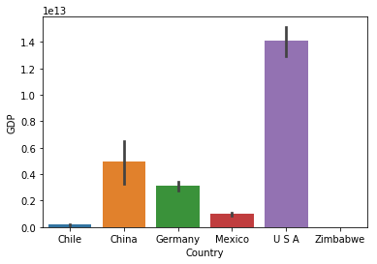

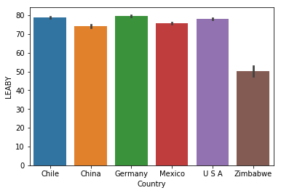

These graphs present an excellent snapshot of the relative differences and similarities in the data we are looking at.

Please note the size difference in the US economy relative to the other nations in the study. This seeming advantage has not manifested in a material difference in LEABY with the other nations in the study, excepting Zimbawbe.

Clearly, size of the economic activity does not mean the people there live the longest. Chile and Germany are excellent examples of bigger is not always better.

Let’s look further.

**What’s happening with GDP in these Countries?**

In the years since the Y2K scare the world economy as a whole has grown rapidly. Sure there have been hick-ups but most nations are seeing growth and expansion as measured by GDP.

Take some time to study the line graphs below. You can see the year by year change in GDP by nation. Sometimes the changes are subtle but overall, each nation’s slope is positive. Everybody is growing.

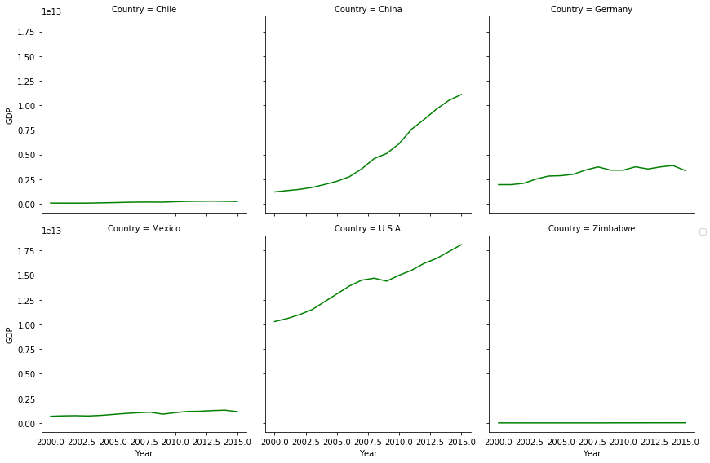

Yes – everybody is growing, even Zimbabwe. In the table below, I have calculated the percentage changes for each of the nations in this study.

|  |  |  |
| --- | --- | --- |
| Country | % Gain in GDP 2000-16 | Avg Annual % GDP gain |
| Chile | 211.5% | 13.2% |
| China | 813.4% | 50.8% |
| Germany | 73.1% | 4.6% |
| Mexico | 68.5% | 4.3% |
| USA | 75.7% | 4.7% |
| Zimbabwe | 143.7% | 9.0% |

In this context it is easier to see the dramatic changes that have taken place over the sixteen years in the study. China’s economy is a full eight times larger than it was in 2000. This unprecedented growth took the most populous nation in the world from what was basically an agrarian society and transformed it into an industrial powerhouse. Chile has more than doubled in economic size and Zimbabwe has expanded by almost one and half times.

Germany, Mexico and the USA have had more modest gains but all still grew at healthy rates.

OK – everybody is experiencing economic expansion, but so what? What does this mean for the nation’s people? Are they better off because of growth in GDP?

**What’s happening with LEABY in these Countries?**

At this stage in my analysis I will make a broad assumption. The assumption is that GDP can also be interpreted as a measure of quality of life. I make this assumption because greater economic activity generally benefits the people undertaking the economic activity. I say generally because in most cases, the trade off for more work is less play. That stinks right? Well, that depends on the individual. People tend to feel a mitigation in this loss of leisure through the ability to buy and consume more.

If we look at this on a macro level, nations being made up of people, the GDP gains translate into increased spending on things that can help a nation keep improving it’s GDP in the long run. These things tend to benefit the people of a nation and improve their quality of life. For example – a country may decide to improve its roads. This means people and goods can move around easier and cheaper. If someone is sick or hurt, they can get to care faster. In addition to infrastructure, the same happens for institutions within a country. Improvements to schools, hospitals, government etc. take place.

Yes, there are exceptions to this and thankfully these exceptions are becoming fewer. Countries for the most part are seeing the benefits associated with reinvesting their GDP gains to cement gains and foster greater future growth.

Part of this investment is measured in the life expectancy of a nations people. I think it is difficult to argue that weak and sickly citizens are positive for economic growth. On the whole, healthy people are cheaper than sick ones.

So – how do our countries stack up in LEABY? Have a look:

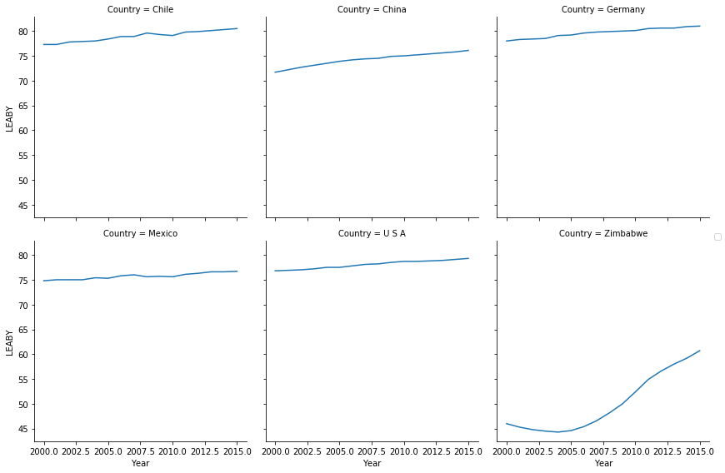

This is great news! All the countries in this study are improving LEABY. **Living standards appear to be correlated with GDP gains.** That said we need to dig a little deeper.

Take a look at this violin plot. This shows the distribution of the changes in LEABY by country.

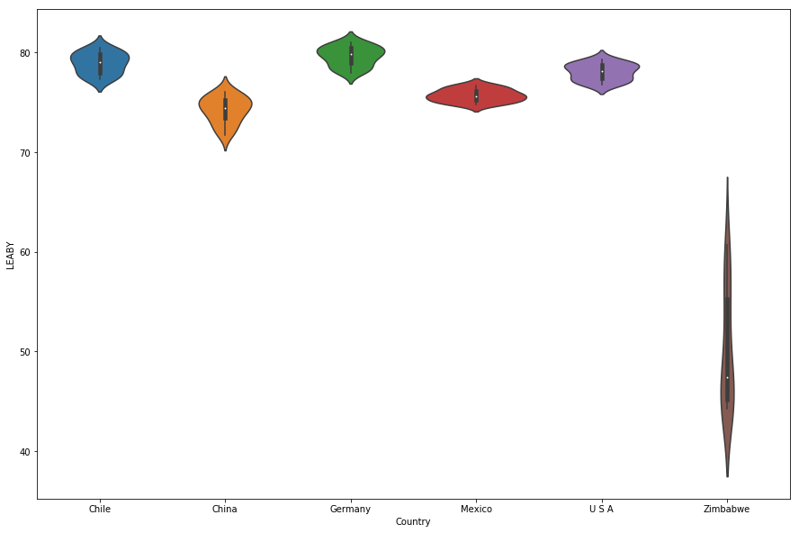

Very Interesting! The larger more developed nations have much higher population concentrations among a much smaller range. Zimbabwe on the other hand has a low concentration spread over a much larger range.

Why are we seeing this type of result in our data? There interpretations are legion. For the more developed and larger nations, maybe the human population is topping out at around 80 years and to breach this plateau the expenditure of GDP as a percentage of the whole, needs to increase materially for items that would directly impact/improve life expectancy.

For Zimbabwe, maybe it is as simple as improving access to clean water or as complex as the world as a whole was/is horrified that in the modern age, a country should have a LEABY at under 40 years of age. In addition to Zimbabwe’s GDP growth there are many nations now contributing to the care and feeding of her people.

The datasets in our study are limited in this regard. Additional research would need to be done to ascertain the reasons behind the gains and to see if we can definitively tie GDP increases to LEABY increases.

This table highlights the amazing improvements over the sixteen years in our analysis:

|  |  |  |  |  |
| --- | --- | --- | --- | --- |
| Country | 2015 Life Expectancy | LEABY Gain 2000-16 | % LEABY Improvement | Avg annual LEABY % gain |
| Chile | 80.5 | 3.2 | 4.1% | 0.3% |
| China | 76.1 | 4.4 | 6.1% | 0.4% |
| Germany | 81.0 | 3 | 3.8% | 0.2% |
| Mexico | 76.7 | 1.9 | 2.5% | 0.2% |
| USA | 79.3 | 2.5 | 3.3% | 0.2% |
| Zimbabwe | 60.7 | 14.7 | 32.0% | 2.0% |

As you can see, the more developed nations have had more modest improvements to LEABY over the sixteen years in our study. Zimbabwe has improved a whopping 32%, adding on average 14.7 years to their life expectancy. Truly remarkable.

That said – I must acknowledge the very much lower starting point in Zimbabwe. Zimbabwe may just be picking low hanging fruit with regard to LEABY. True long term sustained gains that would bring their average to levels of the other nations in the study will hopefully be seen in the future and I’d expect to see their growth rate slow substantially. The other five nations in our study are very much clustered around the 75-year mark. Gains on the level of Zimbabwe would push the LEABY in the other five nations to about 101.25 years. In order for that to occur the world’s medical knowledge/ability would need to advance to Star Trek levels.

**Can we conclude that there appears to be a correlation between changes in GDP and changes in LEABY?**

Yes, I think we can conclude there is a correlation between GDP and LEABY. Examine the scatter plots below. The correlated movements in the positive directions of both GDP and LEABY are evident. This is a powerful visualization and I encourage you to envision the individual graphs passing like an old time flip book.

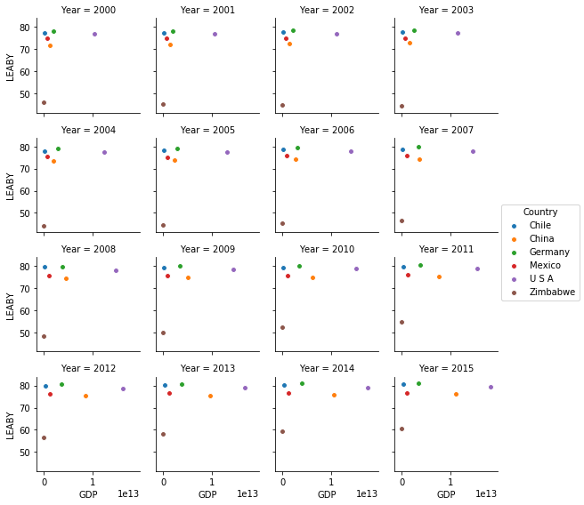

The improvements to LEABY are on the vertical and the gains in GDP can be seen with movements to the right.

Or said in a line graph of the combined data for all countries in this study… see below:

Clearly, the lines move together.

To me, the data is clearly correlated but I do not believe the correlation is as solid and immediate as the data suggests. The impact of the financial crisis in 2008-9 is evident but notice there is no impact on the LEABY. I’d expect LEABY to have more of a lagging relationship to GDP because the impact of improvements take time to show in the overall LEABY of a nation. Sustained GDP growth over a long period of time may have a stronger correlation to LEABY. Maybe using a larger time frame and offsetting the years in comparison – maybe looking at a 5, 10 or 20 year offset – set the GDP at 1995 compared to the LEABY in 2000, 2005, 2015 respectively. That said – the slope and shape of the lines are compelling.

I will leave you with a small data table quantifying the overall percentage changes to both GDP and LEABY for the nations in this study. This table highlights’ the correlation between GDP and LEABY but also allows you to see the difference in degree of correlation.

|  |  |  |
| --- | --- | --- |
| Country | % Gain in GDP 2000-16 | % LEABY Improvement |
| Chile | 211.5% | 4.1% |
| China | 813.4% | 6.1% |
| Germany | 73.1% | 3.8% |
| Mexico | 68.5% | 2.5% |
| USA | 75.7% | 3.3% |
| Zimbabwe | 143.7% | 32.0% |

Comments and feedback are appreciated. Thank you for your time. - CK